**Huilin**

*Sprint 1*

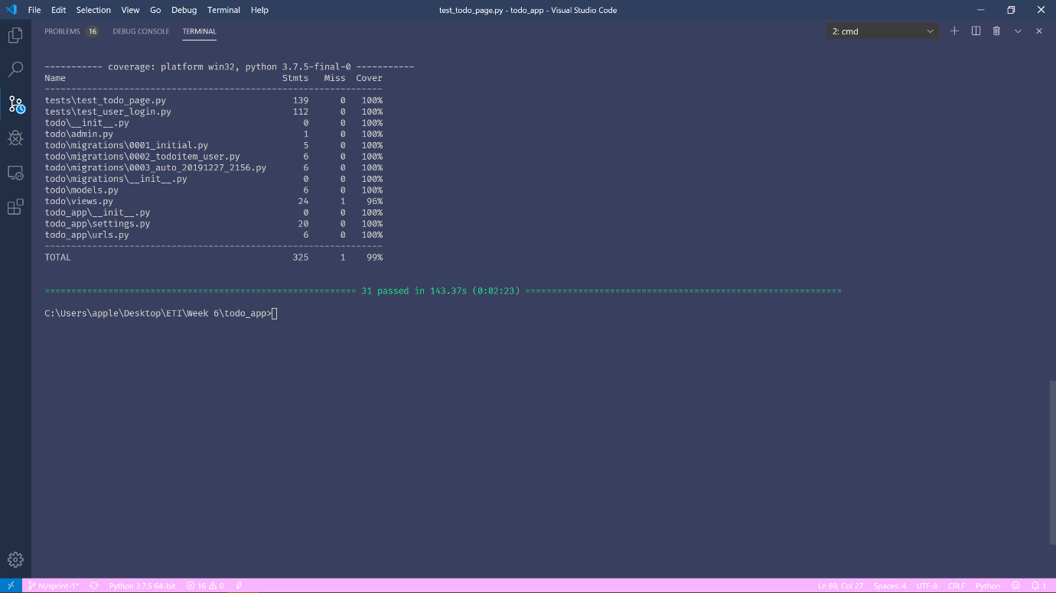

*Sprint 2*

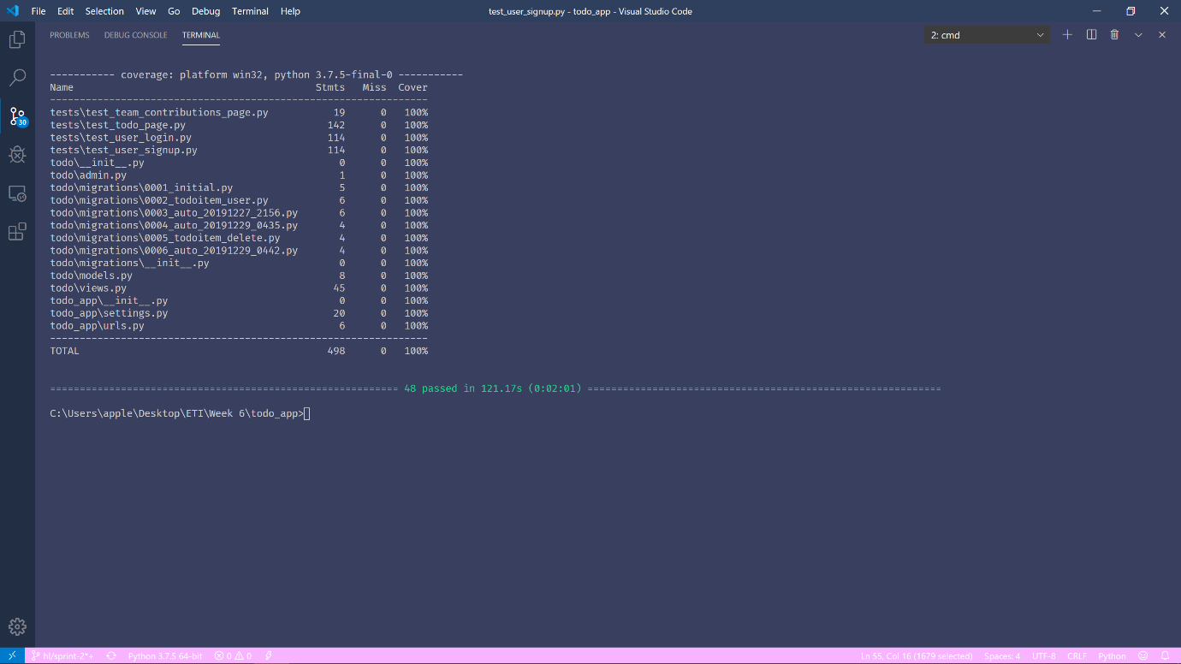

*Justifications*

1. Required error from html input cannot be tested using selenium. Thus, only tested that the browser remained at the same page.
2. The coverage that is missing is from the Team Contributions page view that is not tested.